Address to Council by Nigel Gibson

Why Oxford City Council Could and Should Deliver the Services the People of Oxford Want and Need
I am here this evening to hand over the seventh petition from the people of Oxford, who are clearly expressing their wish, yet again, that you keep Temple Cowley Pools and Fitness Centre open.

I realise that many of you regard the matter of closing Temple Cowley Pools as history, as
something you’ve made a decision on years ago and so shouldn’t have to consider again.
But, the people, your voters, have a very different view, and express it plainly by choosing to sign the petition. They are extremely angry that you are wasting their money and ignoring what they want.

The people of Oxford want their services for health and exercise kept open, provided in a place where they want and need them, at Temple Cowley Pools and Fitness Centre. You must recognise just how strongly people feel about this issue. The first petition presented to you in 2010 was the largest in the history of Oxford at over 12,000 signatures. We only stopped collecting signatures because you chose to ignore the petition – so we started another petition, and another, and another… The strength of feeling remains the same – people are angry now that you continue ignoring them, just as you ignored them when you carried out your so-called ‘consultation’ process.

But it’s not just about opinion; you would have us believe that this is a matter on which people can ‘reasonably differ’ in their views and that as you are in power your view must prevail. But the mantra of Labour has been for many years to follow ‘evidence-based’ policy making. And in this case it is not just opinion that is against you, but evidence. Councillors have claimed that you took “quite a lot of persuading” before deciding to close Temple Cowley Pools. Well, despite all the claims to be following an open and transparent process, at no point have we seen any evidence to justify closure that is either persuasive or even mildly convincing. We have repeatedly asked to see any evidence of what persuaded you; our requests have been met with patronising responses along the lines of ‘we must trust the experts’, even though it is clear that your ‘experts’, your hired hands, are only interested in delivering the message you want to hear.

We have demonstrated, either using information you have provided, or using information we have had to drag out of the council using Freedom of Information requests, how all this so-called ‘evidence’ of yours is a combination of misleading, inaccurate, incomplete and untrue. And that is unfortunate, because as a Campaign we would rather work with you than against you. And this evening, yet again, with yet another petition (now of course the largest number of petitions on one topic ever to have been presented to this council) you have the opportunity to do the right thing.

You have decided to continue to build a 25m, non-Olympic swimming pool at Blackbird Leys. The total cost of this exercise, not just the current build cost of £9.23m, will be over £13m
by the time you have finished. This is the most expensive 25m swimming pool in the UK, and probably in Europe – that is over half a million pounds for each metre!

And you intend closing two sports centres in the process, despite your claims in an answer at the last City Executive Board that “there is no policy of reducing publicly funded leisure facilities” – really? I think it is clear that you are most definitely reducing facilities that people want and need, moving them away from where they want and need them. There is absolutely zero evidence of demand for a new swimming pool at Blackbird Leys – if people there really wanted more swimming, there would be a clamour for the existing pool to be open to the public much longer than the 9 hours it currently is each week.

If you had taken a different course, you could have protected all your front-line services from the swingeing cuts in your Central Government grant, and fully refurbished Temple Cowley Pools, and have done what everyone wants – to keep facilities for health and fitness where they should be – in walking and cycling distance of most of the existing users. And you have chosen a different route, to proceed with your white elephant of a vanity project. But there is still time. Time to keep Temple Cowley Pools open, and do what the public wants.

I’m not going to revisit all the sound, robust and factual evidence for keeping Temple Cowley Pools open, as the Campaign has presented them to you many times before, and each time you’ve chosen to ignore them. Ignore what was the most popular leisure centre despite you actively trying to run it down, ignore that it was the most energy efficient leisure centre, ignore that it is sited in Oxford’s area of fastest population growth over the last ten years, ignore the independent condition surveys that you commissioned and then hid because they told you there is nothing basically wrong with it.

At the heart of your desire to close Temple Cowley Pools is money, or rather, ‘you say’ saving it. We hear repeatedly that it costs us over £500,000 a year to operate the centre. You claim that the vast majority of that, £340,000 last year, is a contractual payment to the operators, Fusion, who also take all the admission money while operating a tax avoidance scam under the pretence of being a charity.

Well, you publish the annual payments from the Fusion contract on your website. Here they are, for the whole contract term:

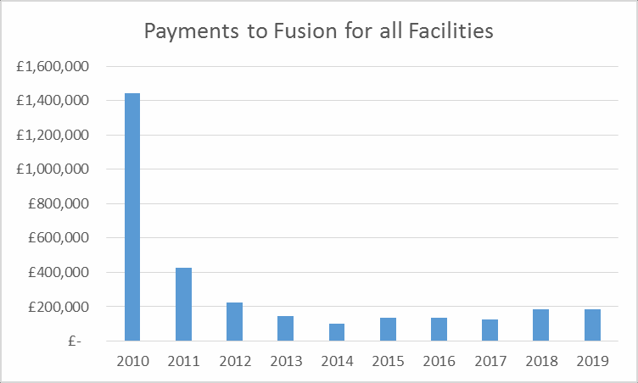

And you claimed in an answer to a public question at a City Executive Board meeting last year that nothing had changed, and that you are not paying anything additional to Fusion. You will see quite clearly that the payments last year were under £200,000 for all our leisure centres, so clearly there’s some adding up going wrong in your claim for the operating costs of Temple Cowley. Or someone is lying?

And you can see, quite clearly, that the annual payments to Fusion will stay below £200,000 for the rest of the contract. And yet for the brand new 25m non-Olympic swimming pool
you are going to pay Fusion £150,000 a year! How on earth can this be value for money?

Here’s a solution. The maintenance cost of Temple Cowley Pools is under £100,000 a year. The real contract ‘cost’ to Fusion for operating the centre cannot be more than about
£30,000 a year. You can bring the diving pool back into use for £60,000 – the only publicly funded diving pool in Oxfordshire . The only major costs in maintenance, according to your own figures, are the air handling units and the roof – these will cost £300,000. So here is a real value-for-money solution that trumps anything else you are doing anywhere else in Oxford; cheaper to enact and cheaper to run than the new swimming pool, offering more facilities that will enable and preserve the health, fitness, well-being and quality of life of thousands of people in Oxford and across the county. None more so than the elderly and infirm, who rely on this health and fitness centre being where it is now as convenient for them to exercise and maintain their quality of life, enabling them to remain independent and out of the costly clutches of the NHS.

And so, supported by the solution I have just described, I would like to present you with the seventh petition from the people of Oxford:

"We the undersigned strongly oppose Oxford City Council's plan to demolish Temple Cowley Pools and Fitness Centre in order to sell publicly owned land for housing. We believe this is a short-sighted, destructive policy which will have detrimental effects on health and well-being, particularly of the most vulnerable people, who use the centre to maintain their health and quality of life, and independence from the NHS for as long as possible. We call upon Oxford City Council to work immediately with the Save Temple Cowley Pools Campaign to find the best way to enhance and preserve the existing facilities in Temple Cowley."

Nigel Gibson – February 2014
Campaign to Save Temple Cowley Pools & Fitness Centre savetcp@gmail.com www.savetemplecowleypools.webs.com
@savetcp
fb: savetcp

